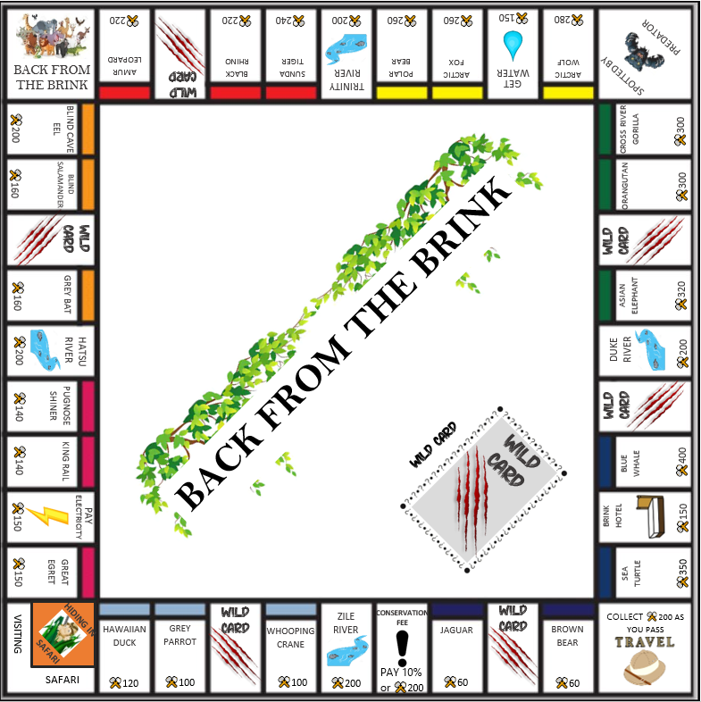





(Species) Biome

x 2 or 3 =

(Species) Habitat

x 1 =



x2

x2

x3

x3

x3

x3

x3

x3

Exotic Biome



Snow Biome

Jungle Biome

Marine Biome

Forest Biome

Sky Biome

Wetlands Biome

Cave Biome

* Sunda Tiger Cost: ⚒️240
* Black Rhino Cost: ⚒️220
* Amur Leopard Cost: ⚒️220
* Blind Cave Eel Cost: ⚒️200
* Blind Salamander Cost: ⚒️160
* Grey Bat Cost: ⚒️160



All rivers cost ⚒️200 to cross

* Pugnose Shiner Cost: ⚒️140

Electricity costs ⚒️150

* King Rail Cost: ⚒️140
* Great Egret Cost: ⚒️160



Collecting Water costs ⚒️150



Staying at Brink Hotel costs ⚒️150

* Hawaiian Duck Cost: ⚒️120
* Grey Parrot Cost: ⚒️100
* Whooping Crane Cost: ⚒️100

Pay 10% or ⚒️200





* Jaguar Cost: ⚒️60

Roll a double or use ⚒️50 to escape

* Brown Bear Cost: ⚒️60



Save at least one Biome and have at least ⚒️1,000 to ‘purchase’ WINNING SQUARE!

* A picture containing food, bird, game

  Description automatically generatedSea Turtle Cost: ⚒️350
* Advance to Jaguar.
* Advance to Blue whale.
* Advance to the nearest River.
* Advance to Travel square.
* Go back 3 squares.
* You have been spotted by a predator, advance to Hiding in Safari.
* A rescue team has spotted you in the Safari, use this card to escape from the Safari. (x2)
* You have won a conservation grant, collect ⚒️ 200.
* You have been assessed for grounds maintenance, ⚒️ 40 per house and ⚒️ 75 per hotel.
* A breeding program has been very successful, collect ⚒️ 100 for each owned Habitat.
* You have been elected chairman of IUCN, pay ⚒️ 50.
* It is the end of the month, pay ⚒️ 100 for food bills.
* Conservation Fee refund collect ⚒️ 200.
* Collect ⚒️ 50 off every player to help with your conservation scheme.
* Blue Whale Cost: ⚒️400



* Asian Elephant Cost: ⚒️320
* Orangutan Cost: ⚒️300
* Cross River Gorilla Cost: ⚒️300



* Arctic Wolf Cost: ⚒️280
* Arctic Fox Cost: ⚒️260
* Polar Bear Cost: ⚒️260

PRICE ⚒️60 RENT ⚒️4  
_______________________________

With 1 Zoo ⚒️20  
With 2 Zoo ⚒️60  
With 3 Zoo ⚒️180  
With 4 Zoo ⚒️320  
With NATIONAL PARK ⚒️450  
_______________________________  
 One Zoo costs ⚒️50  
_______________________________

PRICE ⚒️60 RENT ⚒️2  
_______________________________

With 1 Zoo ⚒️10  
With 2 Zoo ⚒️30  
With 3 Zoo ⚒️90  
With 4 Zoo ⚒️160  
With NATIONAL PARK ⚒️250  
_______________________________  
 One Zoo costs ⚒️50  
_______________________________

**JAGUAR**

**BROWN BEAR**

PRICE ⚒️400 RENT ⚒️50  
_______________________________

With 1 Zoo ⚒️200  
With 2 Zoo ⚒️600  
With 3 Zoo ⚒️1400  
With 4 Zoo ⚒️1700  
With NATIONAL PARK ⚒️2000  
_______________________________  
 One Zoo costs ⚒️200  
_______________________________

PRICE ⚒️350 RENT ⚒️35  
_______________________________

With 1 Zoo ⚒️175  
With 2 Zoo ⚒️500  
With 3 Zoo ⚒️1100  
With 4 Zoo ⚒️1300  
With NATIONAL PARK ⚒️1500  
_______________________________  
 One Zoo costs ⚒️200  
_______________________________

**SEA TURTLE**

**BLUE WHALE**

**ASIAN ELEPHANT**

PRICE ⚒️320 RENT ⚒️28  
_______________________________

With 1 Zoo ⚒️150  
With 2 Zoo ⚒️450  
With 3 Zoo ⚒️1000  
With 4 Zoo ⚒️1200  
With NATIONAL PARK ⚒️1400  
_______________________________  
 One Zoo costs ⚒️200  
_______________________________

PRICE ⚒️300 RENT ⚒️26  
_______________________________

With 1 Zoo ⚒️130  
With 2 Zoo ⚒️390  
With 3 Zoo ⚒️900  
With 4 Zoo ⚒️1100  
With NATIONAL PARK ⚒️1275  
_______________________________  
 One Zoo costs ⚒️200  
_______________________________

**CROSS RIVER GORILLA**

PRICE ⚒️300 RENT ⚒️26  
_______________________________

With 1 Zoo ⚒️130  
With 2 Zoo ⚒️390  
With 3 Zoo ⚒️900  
With 4 Zoo ⚒️1100  
With NATIONAL PARK ⚒️1275  
_______________________________  
 One Zoo costs ⚒️200  
_______________________________

**ORANGUTAN**

PRICE ⚒️240 RENT ⚒️20  
_______________________________

With 1 Zoo ⚒️100  
With 2 Zoo ⚒️300  
With 3 Zoo ⚒️750  
With 4 Zoo ⚒️925  
With NATIONAL PARK ⚒️1100  
_______________________________  
 One Zoo costs ⚒️150  
_______________________________

PRICE ⚒️220 RENT ⚒️18  
_______________________________

With 1 Zoo ⚒️90  
With 2 Zoo ⚒️250  
With 3 Zoo ⚒️700  
With 4 Zoo ⚒️875  
With NATIONAL PARK ⚒️1050  
_______________________________  
 One Zoo costs ⚒️150  
_______________________________

PRICE ⚒️220 RENT ⚒️18  
_______________________________

With 1 Zoo ⚒️90  
With 2 Zoo ⚒️250  
With 3 Zoo ⚒️700  
With 4 Zoo ⚒️875  
With NATIONAL PARK ⚒️1050  
_______________________________  
 One Zoo costs ⚒️150  
_______________________________

PRICE ⚒️280 RENT ⚒️24  
_______________________________

With 1 Zoo ⚒️120  
With 2 Zoo ⚒️360  
With 3 Zoo ⚒️850  
With 4 Zoo ⚒️1025  
With NATIONAL PARK ⚒️1200  
_______________________________  
 One Zoo costs ⚒️150  
_______________________________

PRICE ⚒️260 RENT ⚒️22  
_______________________________

With 1 Zoo ⚒️110  
With 2 Zoo ⚒️330  
With 3 Zoo ⚒️800  
With 4 Zoo ⚒️975  
With NATIONAL PARK ⚒️1150  
_______________________________  
 One Zoo costs ⚒️150  
_______________________________

**SUNDA TIGER**

**BLACK RHINO**

PRICE ⚒️260 RENT ⚒️22  
_______________________________

With 1 Zoo ⚒️110  
With 2 Zoo ⚒️330  
With 3 Zoo ⚒️800  
With 4 Zoo ⚒️975  
With NATIONAL PARK ⚒️1150  
_______________________________  
 One Zoo costs ⚒️150  
_______________________________

**AMUR LEOPARD**

**ARCTIC WOLF**

**ARCTIC FOX**

**POLAR BEAR**

**PUGNOSE SHINER**

PRICE ⚒️140 RENT ⚒️10  
_______________________________

With 1 Zoo ⚒️50  
With 2 Zoo ⚒️150  
With 3 Zoo ⚒️450  
With 4 Zoo ⚒️625  
With NATIONAL PARK ⚒️750  
_______________________________  
 One Zoo costs ⚒️100  
_______________________________

PRICE ⚒️120 RENT ⚒️8  
_______________________________

With 1 Zoo ⚒️40  
With 2 Zoo ⚒️100  
With 3 Zoo ⚒️300  
With 4 Zoo ⚒️450  
With NATIONAL PARK ⚒️600  
_______________________________  
 One Zoo costs ⚒️50  
_______________________________

PRICE ⚒️100 RENT ⚒️6  
_______________________________

With 1 Zoo ⚒️30  
With 2 Zoo ⚒️90  
With 3 Zoo ⚒️270  
With 4 Zoo ⚒️400  
With NATIONAL PARK ⚒️550  
_______________________________  
 One Zoo costs ⚒️50  
_______________________________

PRICE ⚒️100 RENT ⚒️6  
_______________________________

With 1 Zoo ⚒️30  
With 2 Zoo ⚒️90  
With 3 Zoo ⚒️270  
With 4 Zoo ⚒️400  
With NATIONAL PARK ⚒️550  
_______________________________  
 One Zoo costs ⚒️50  
_______________________________

**HAWAIIAN DUCK**

**GREY PARROT**

**WHOOPING CRANE**

PRICE ⚒️160 RENT ⚒️12  
_______________________________

With 1 Zoo ⚒️60  
With 2 Zoo ⚒️180  
With 3 Zoo ⚒️500  
With 4 Zoo ⚒️700  
With NATIONAL PARK ⚒️900  
_______________________________  
 One Zoo costs ⚒️100  
_______________________________

**GREAT EGRET**

PRICE ⚒️140 RENT ⚒️10  
_______________________________

With 1 Zoo ⚒️50  
With 2 Zoo ⚒️150  
With 3 Zoo ⚒️450  
With 4 Zoo ⚒️625  
With NATIONAL PARK ⚒️750  
_______________________________  
 One Zoo costs ⚒️100  
_______________________________

**KING RAIL**

PRICE ⚒️200 RENT ⚒️16  
_______________________________

With 1 Zoo ⚒️80  
With 2 Zoo ⚒️220  
With 3 Zoo ⚒️600  
With 4 Zoo ⚒️800  
With NATIONAL PARK ⚒️1000  
_______________________________  
 One Zoo costs ⚒️100  
_______________________________

PRICE ⚒️160 RENT ⚒️14  
_______________________________

With 1 Zoo ⚒️70  
With 2 Zoo ⚒️200  
With 3 Zoo ⚒️550  
With 4 Zoo ⚒️700  
With NATIONAL PARK ⚒️950  
_______________________________  
 One Zoo costs ⚒️100  
_______________________________

PRICE ⚒️160 RENT ⚒️14  
_______________________________

With 1 Zoo ⚒️70  
With 2 Zoo ⚒️200  
With 3 Zoo ⚒️550  
With 4 Zoo ⚒️700  
With NATIONAL PARK ⚒️900  
_______________________________  
 One Zoo costs ⚒️100  
_______________________________

**GREY BAT**

**BLIND CAVE EEL**

**BLIND SALAMANDER**